# S.Ajith kumar 192011004

**Exercise NO 7: Use Google and Whois for Reconnaisasance.**

**Aim:** To find out the Whois, DNS Records and Diagonstics for particular website by using Whois search.

# Procedure:

Step1: Open the WHO.is website



Step 2: Enter the website name in search bar and hit the “Enter button”.Step 3: Show you information about

[www.saveetha.com](http://www.saveetha.com/)

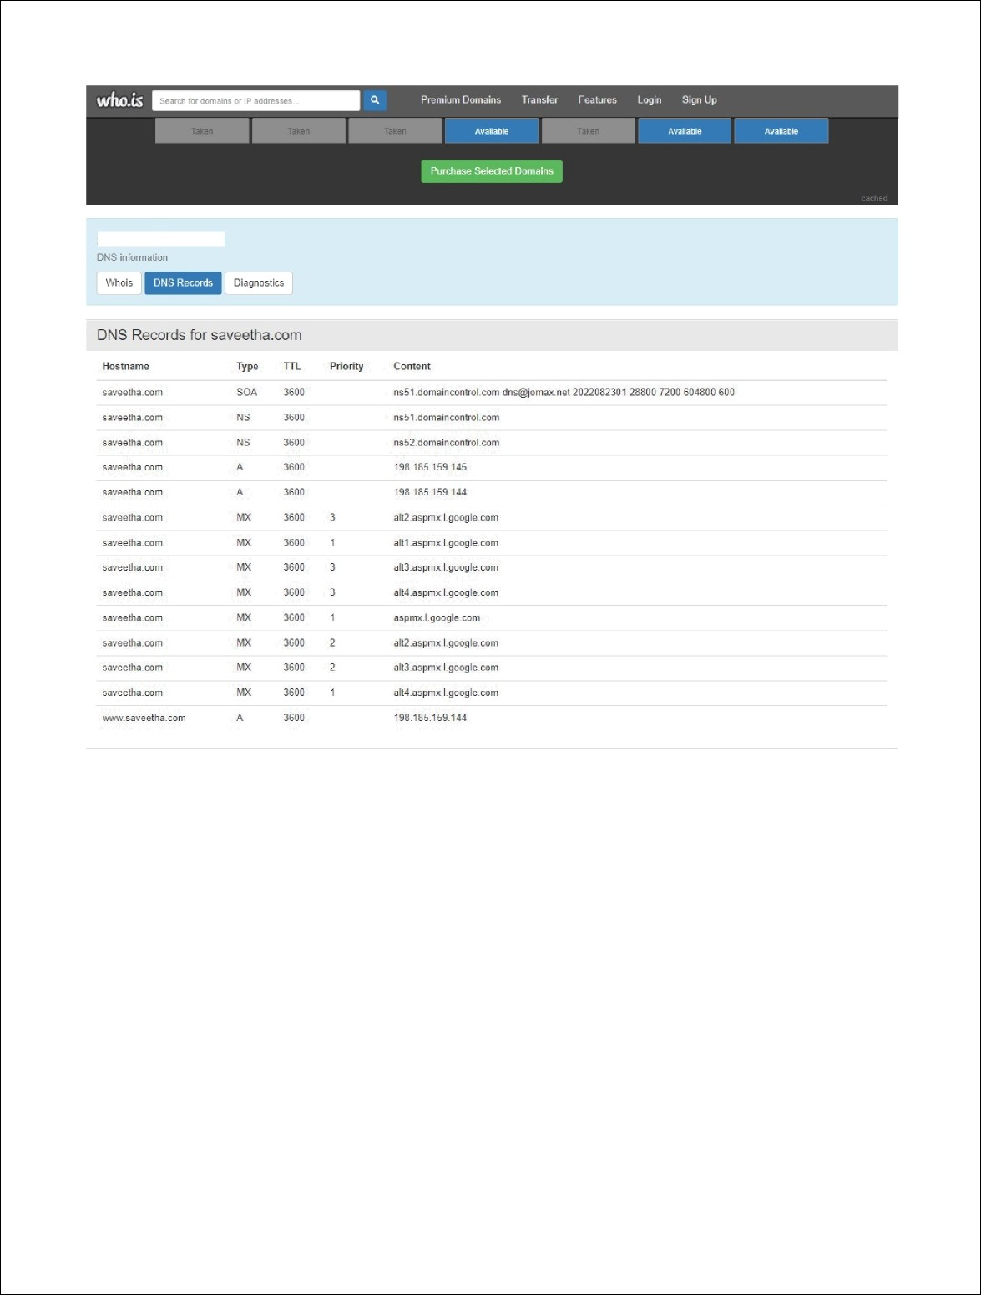

saveetha.com

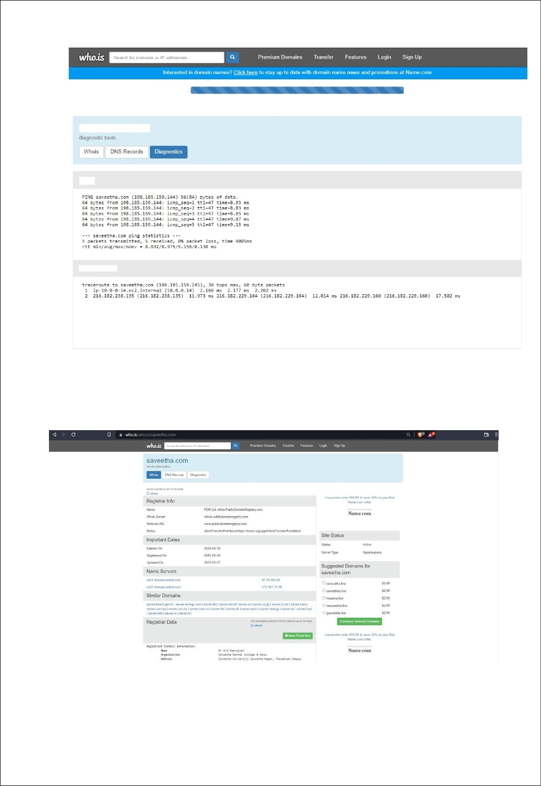

saveetha.com

Ping

Traceroute

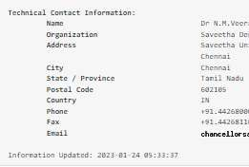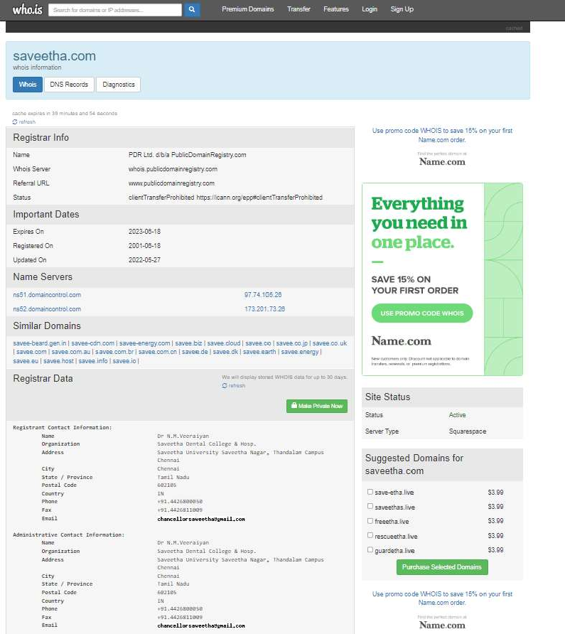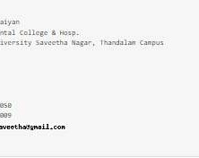

**Output**

1. WHO is

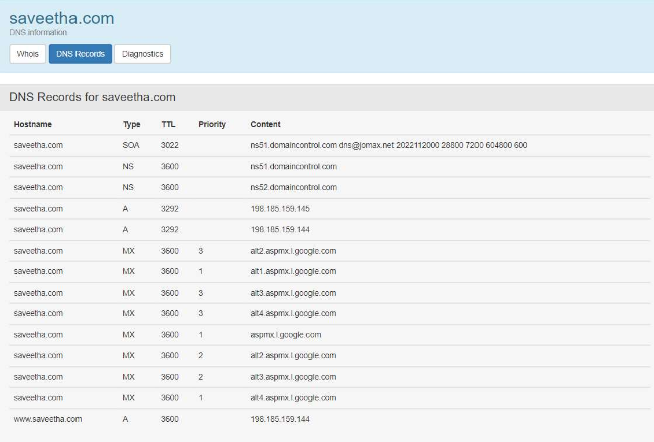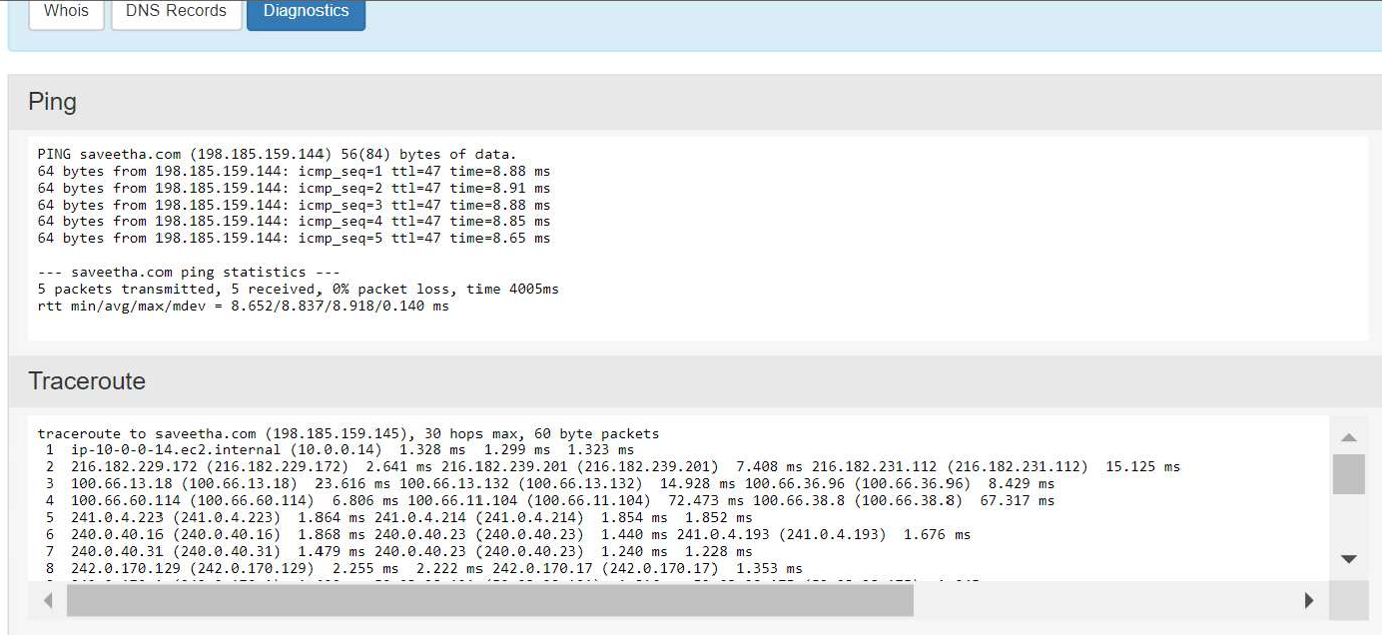

1. DNS
2. Diagnostics

Result

Hence the Whois, DNS Records and Diagonstics for particular website by using Whois search is performed successfully.